Submitting ESS Job Create Accounting FA from OIC For Multiple FA Books

Purpose of the integration:
This integration is designed to satisfy the below requirement.
Requirement : To Create Accounting of Assets for Multiple Book types at a time.
Steps followed are below
- Created DB Adapter Connection.
Connection Name :GetDBValues
- Created ERP Cloud Connection
Connection Name : ErpCloudConnect Adapter

1.DB Adapter Connection :
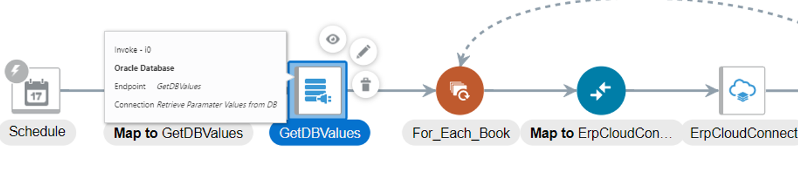
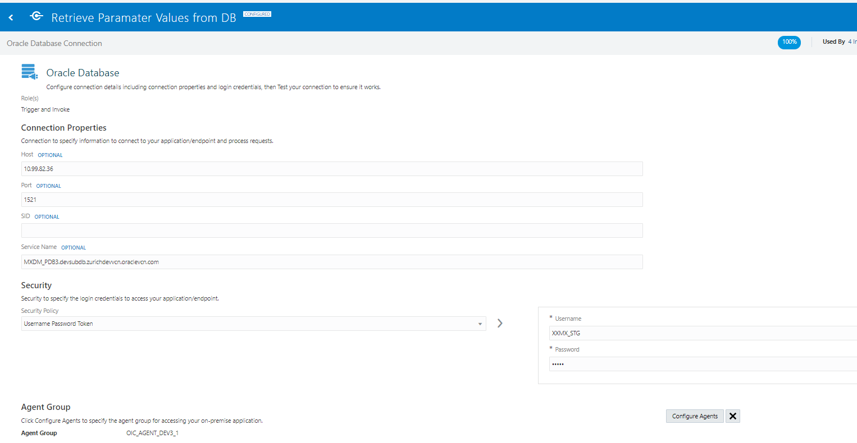
2.ERP Cloud Adapter Connection
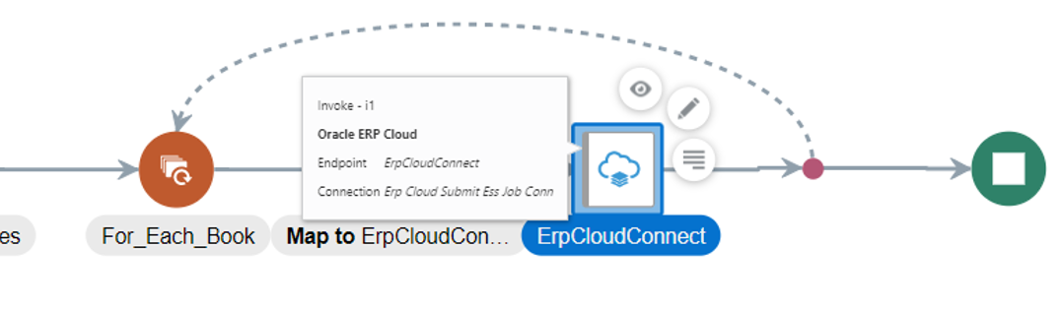
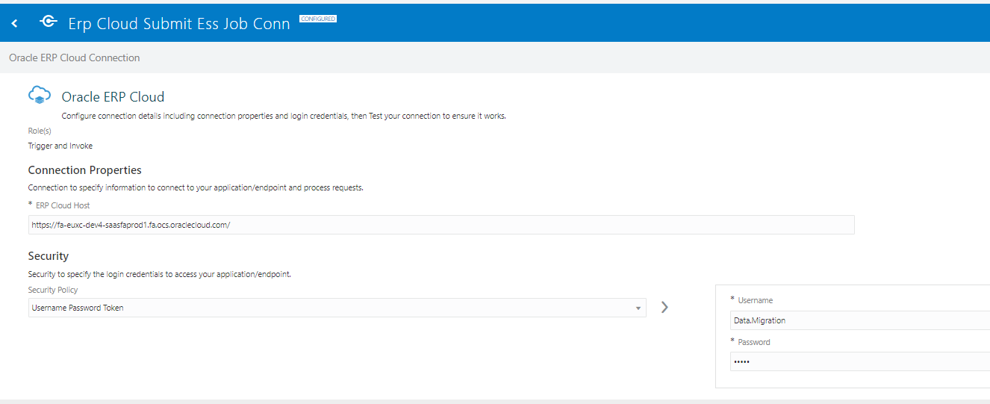
For_Each_Book : We have used For loop component in between the above two connections to iterate through multiple books .
Below is the Design Diagram of the integration developed.
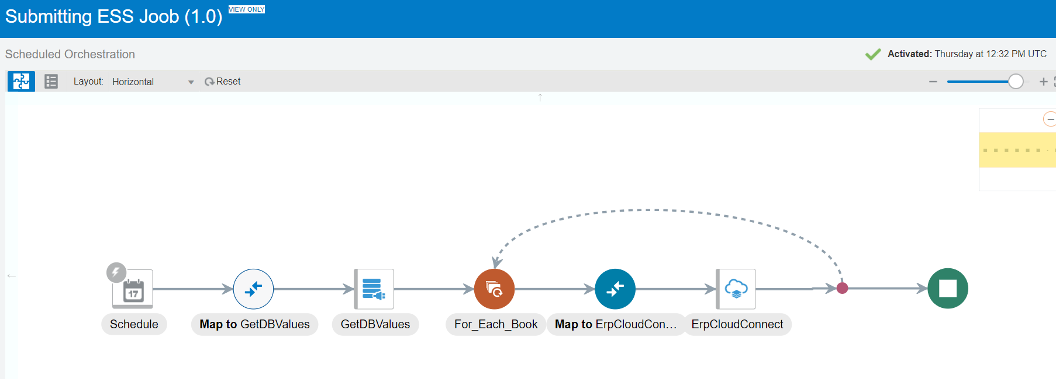

GetDBValues Adapter :The purpose of the DB adapter is to get the Booktype Code values from Database.

Get DB Values DB adapter Configuration
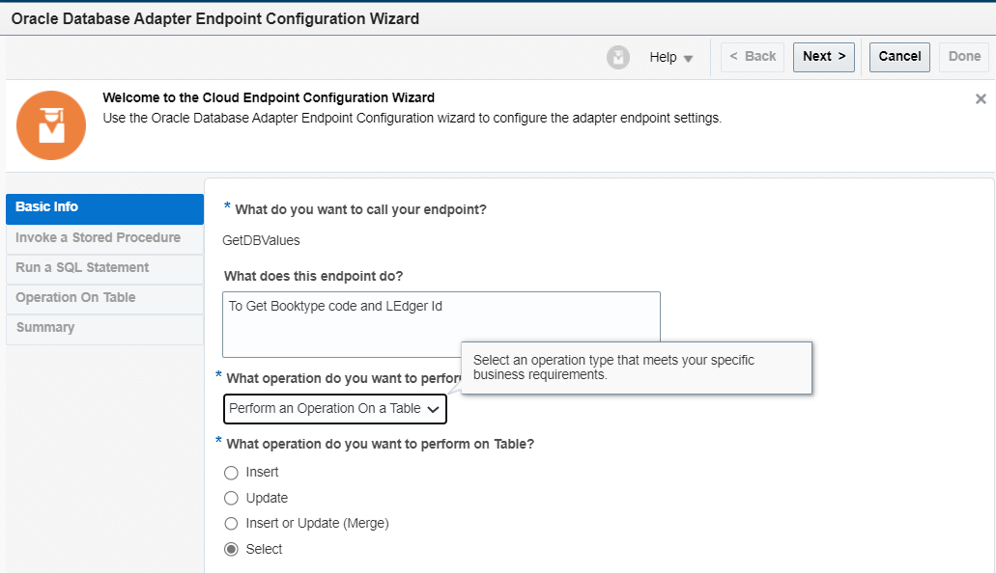
Table Name : XXMX_DM_ASSET_BOOKS_IN_SCOPE
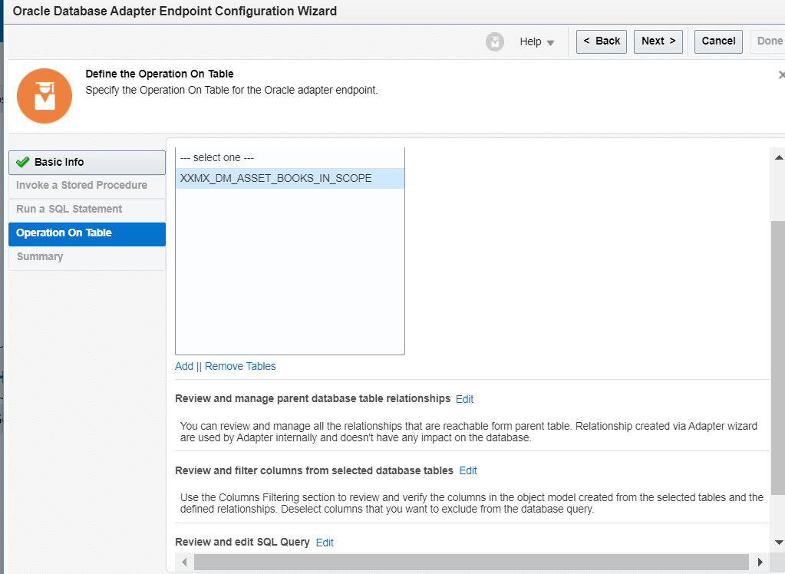

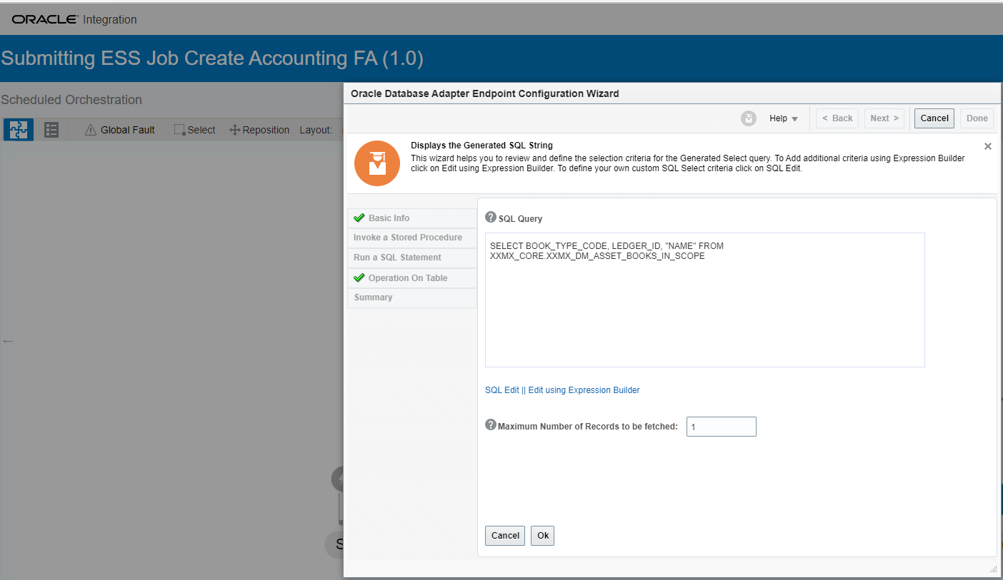

Query Used :

SELECT BOOK_TYPE_CODE,LEDGER_ID “NAME”
FROM XXMX_CORE.XXMX_DM_ASSET_BOOKS_IN_SCOPE
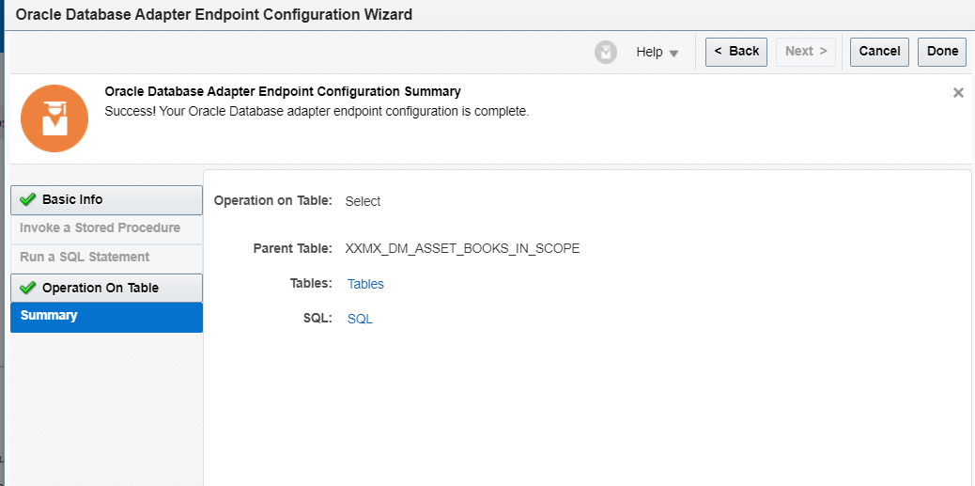

ErpCloud Adapter
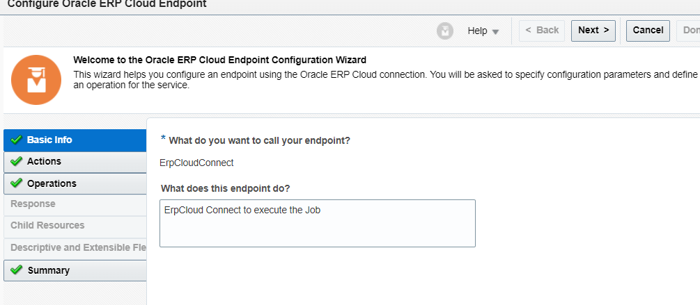

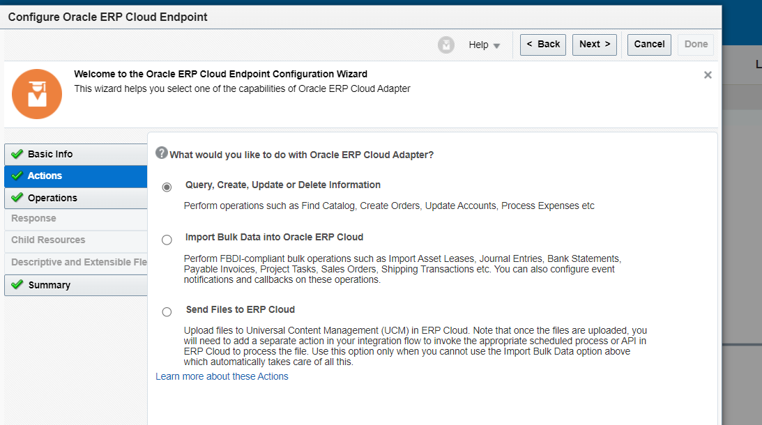
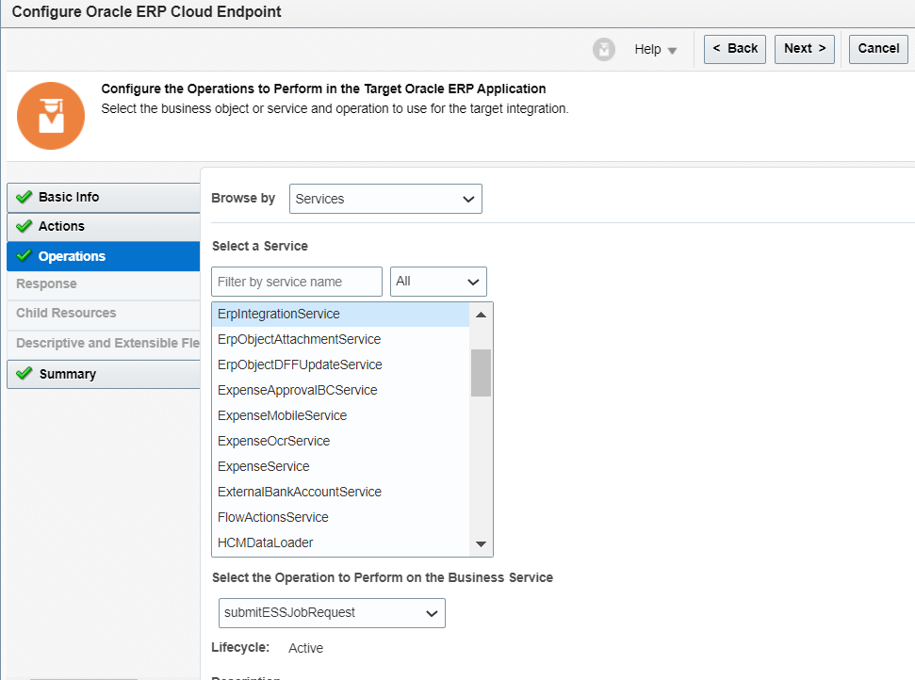
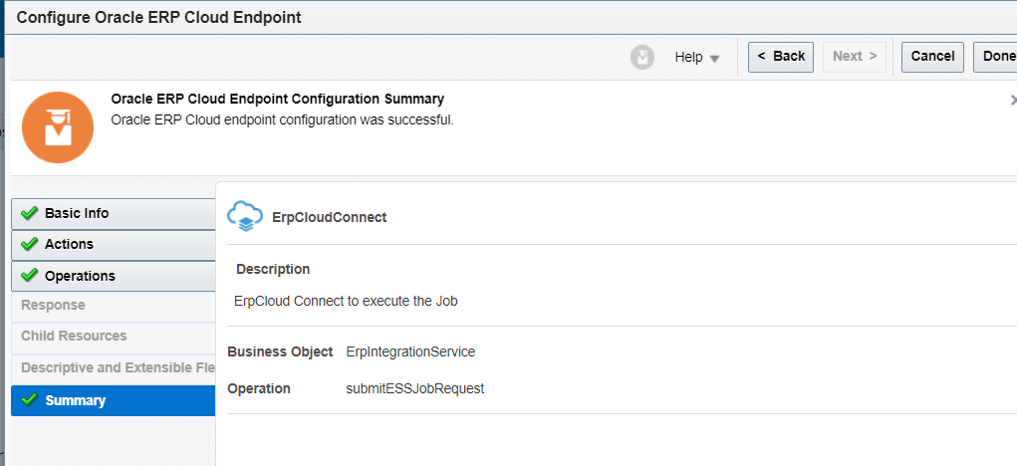

Mapping to ErpCloud Job Parameters

Need to specify here

Job Package Name : '/oracle/apps/ess/financials/assets/shared/'
Job Definition Name : 'FAFSNAPRPT'

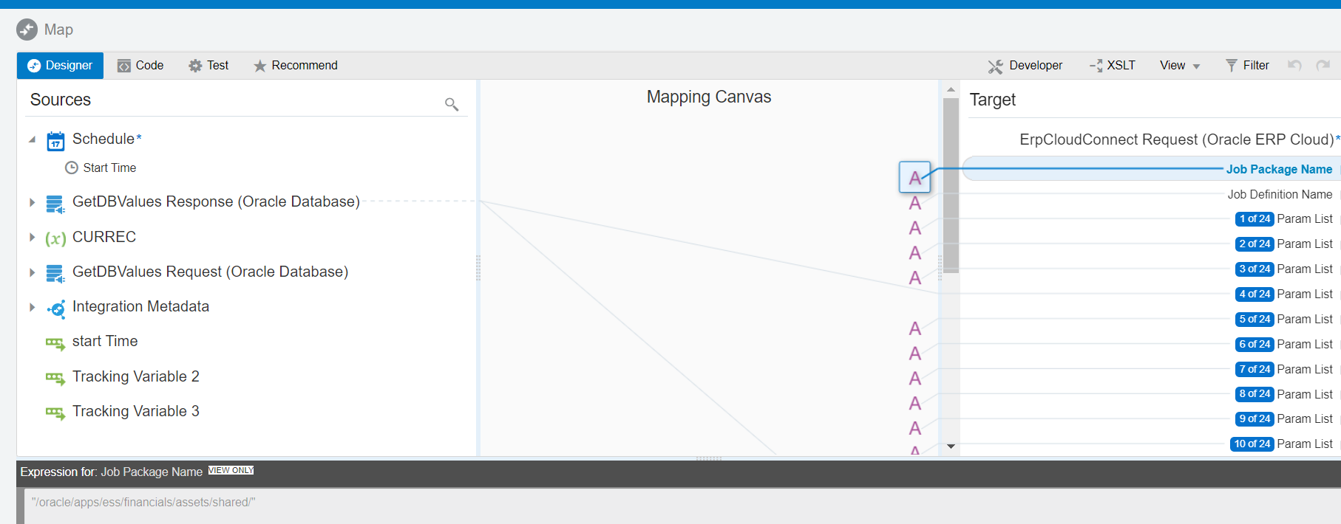
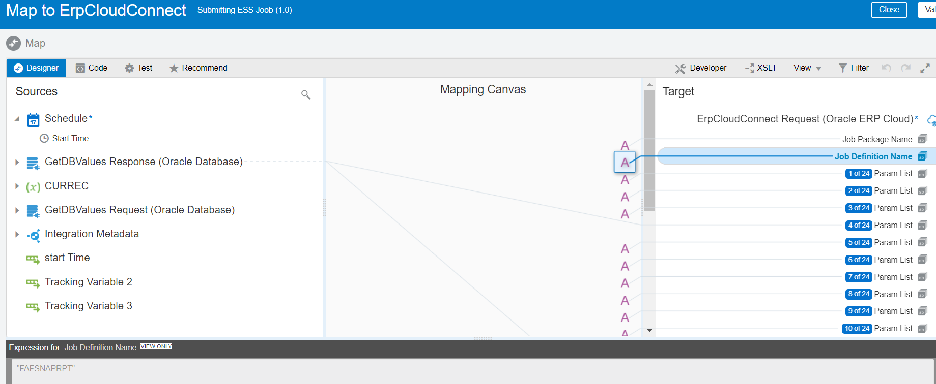

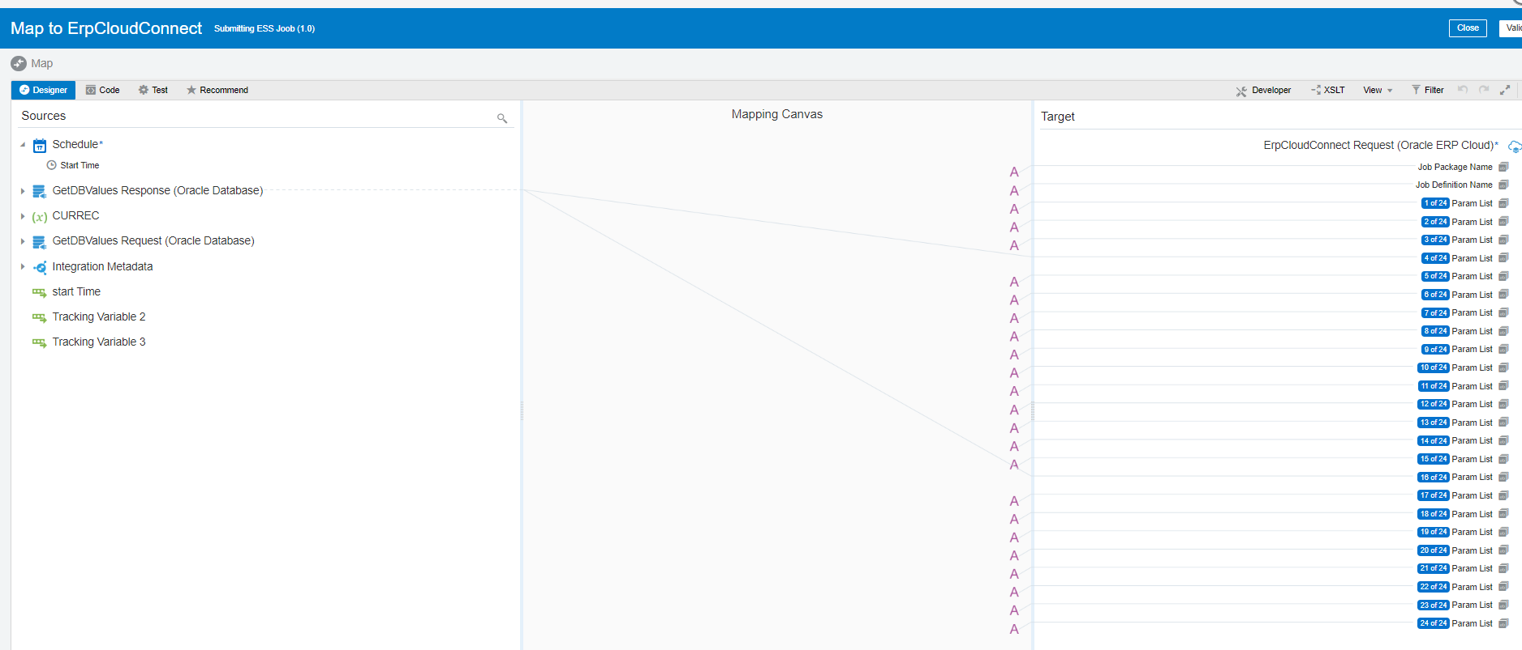

Parameter Name | Value | Description
Parameter1 | NULL
Parameter2 | NULL
Parameter3 | 140 | Business Unit ID
Parameter4 | ledgerid | Ledger ID
Parameter5 | NULL
Parameter6 | 2022-07-31 | End Date
Parameter7 | Y
Parameter8 | F | Accounting Mode
Parameter9 | N | Post in General Ledger
Parameter10 | D | Report Style
Parameter11 | Y
Parameter12 | N | Transfer to General Ledger
Parameter13 | NULL
Parameter14 | NULL
Parameter15 | N | Include User Transaction Identifiers
Parameter16 | bookTypeCode | Book
Parameter17 | NULL
Parameter18 | NULL
Parameter19 | NULL
Parameter20 | NULL
Parameter21 | NULL
Parameter22 | NULL
Parameter23 | NULL
Parameter24 | NULL
Parameter25 | NULL

